Preparing Children
for the Future

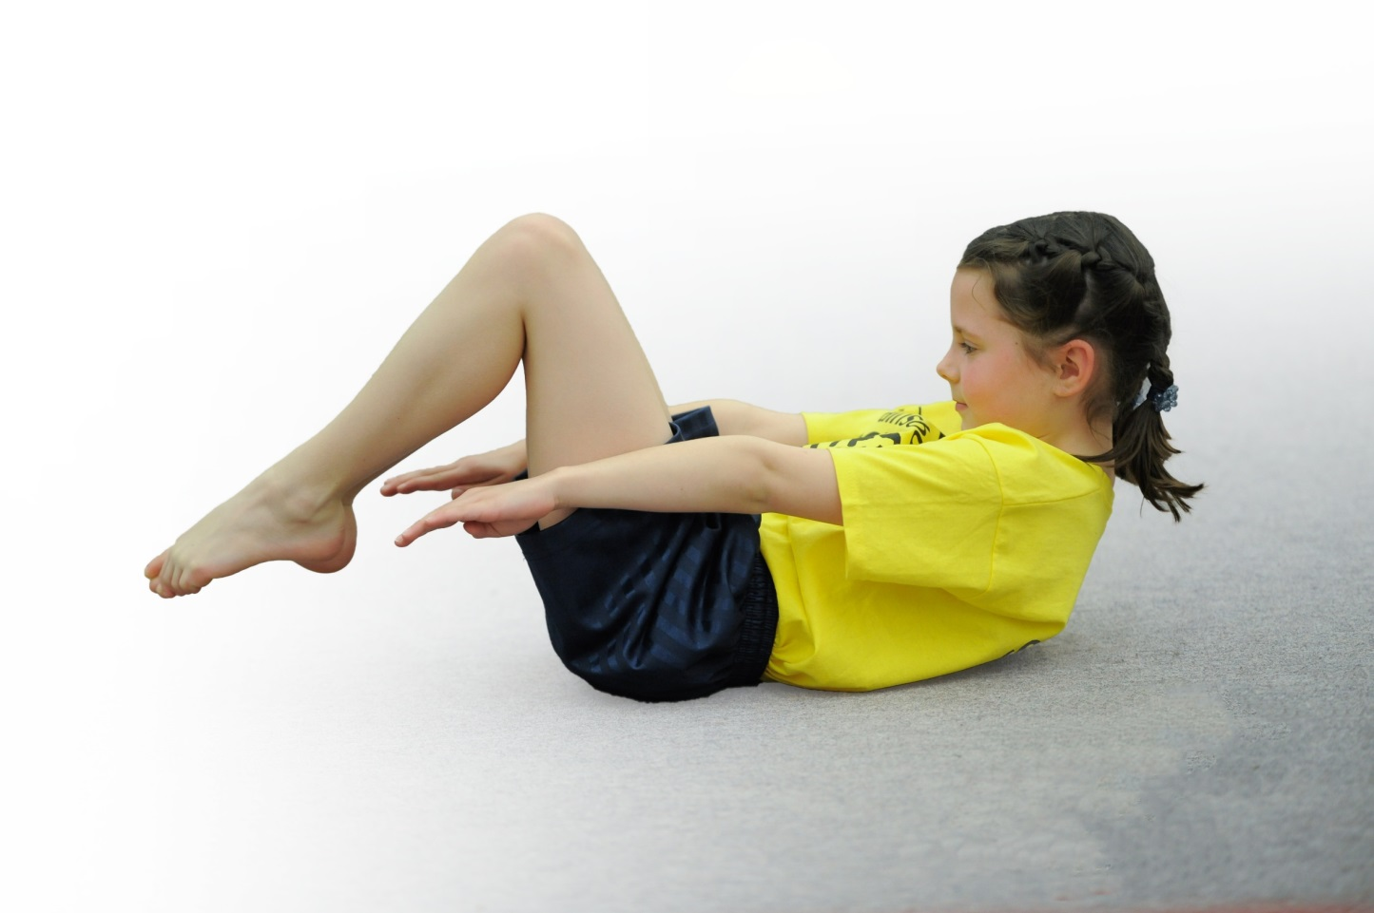



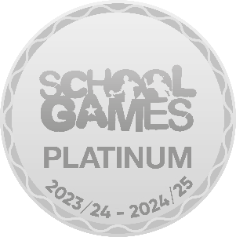
Knowle CE Primary Academy

PRIMARY PE & SPORT PREMIUM REPORT 2023/24


This template can be used for multiple purposes:
by:
- It enables schools to effectively plan their use of the Primary PE and sport premium
- It helps schools to meet the requirements (as set out in guidance) to publish information on their Primary PE and sport premium
- It will be an effective document to support Ofsted inspections enabling schools to evidence progress in Physical Education (PE) and evidence swimming attainment, which forms part of the PE National Curriculum. We would recommend schools consider
the Intent, Implementation and Impact of any spend, as examined within the Education Inspection Framework.

It is important that your grant is used effectively and based on school need.

Schools must use the funding to make additional and sustainable
improvements to the quality of the PE, School Sport and Physical Activity (PESSPA)
they offer. This means that you should use the Primary PE and sport premium to:

- Build capacity and capability within the school to ensure that improvements made now will benefit pupils joining the school in future years
- Develop or add to the PESSPA activities that your school already offers.

The Primary PE and sport premium should not be used to fund capital spend projects; the school’s core budget should fund these. Further detail on capital expenditure can be found in the updated Primary PE and sport premium guidance.

The Primary PE and sport premium guidance, outlines 5 key priorities that funding should be used towards. It is not

necessary that spending has to meet all the key priorities, you should select the priorities that you aim to use any funding towards.

Although completing this template is not a requirement for schools, schools are required to publish details of how they spend this funding. Schools must also outline what the impact this funding has had on pupils’ PE and sport participation and attainment and how any spending will be sustainable in the future. All funding must be spent by 31st July 2024.

The Department for Education has worked closely with the Association for Physical Education (afPE) and the Youth Sport Trust (YST) to develop this template and encourages schools to use it. This template is an effective way of meeting the reporting requirements of the Primary PE and sport premium.
Review of last year’s spend and key achievements (2022/2023)

We recommend you start by reflecting on the impact of current provision and reviewing your previous spend.

Activity/Action | Impact | Comments
Sainsburys School Games Platinum Award achieved  94% of Year 6 achieved NC swimming and water safety  Addition swimming sessions for Year 4 pupils who did not achieve NC in 21/22.  Comprehensive and continuous CPD program for all staff  Active Lunchtimes | - High standards of PE, School Sport and Physical Activity maintained.  - Active Lunchtimes case study shared.  - High levels of engagement in school sport continued  - Pupils are safe in a range of water-based situations.  - 48% of pupils in Year 4 who had additional swimming in the Autumn term passed the NC expected standard. Year group NC pass rate went from 43% to 72%.  - High standards of PE being taught across school  - Staff confident in their PE teaching  - Increase in pupils engaging in lunchtime activities: 37% Autumn 2022 join in with Play Leader activities compared to 25% 21/22.  - 22/23- 80% of pupils reported they either ‘run and play hard most of the time’ or ‘join in with Play Leader’ activities of a lunchtime.  - Fewer behaviour issues during lunchtime- anecdotal evidence from staff.  - 22/23- 75% of pupils rated themselves as 7 or above on physical activity scale (1- not very, 10- very). | Pupils and staff are very proud of our achievement. They enjoy the active lunchtimes and competition calendar.  83% of pupils said they enjoy all or most of their PE lessons.  92% of pupils said they feel confident in their PE lessons.  89% of pupils said they get to learn new skills in their PE lessons.  81% of pupils said they know how to improve their skills in their PE lessons.  95% of pupils said they get to experience different roles in their PE lessons e.g. coaching, self and peer assessing, performing, umpiring.  Active lunchtimes also happening in KS1 with high pupil involvement.

Key priorities and Planning
This planning template will allow schools to accurately plan their spending.

Action – what are you planning to do | Who does this action impact? | Key indicator to meet | Impacts and how sustainability will be achieved? | Cost linked to the action
Inclusions, engagement and school culture: being active enthusiastically promoted with pupils, families and staff engaged in physical activity. All pupils engaged in 30+ minutes of moderate to vigorous daily activity in school, with specific measures to ensure engagement of inactive pupils.  Promote competition and participation in sport for children across all year groups so that pupils can experience a variety of sporting activities and competitions in a safe and nurturing environment.  Implement a range of CPD and team-teaching opportunities as part of a needs-led staff development plan to include high quality, externally provided training, supporting resources and teaching aids. This training will ensure that ALL pupils are able to develop their skills, imagination and creativity across a range of sports and activities and support pupils in the knowing the next steps of their learning journeys. Assessment for learning will be embedded with peer assessment and collaborative learning integral to all lessons.  Provide additional swimming provision targeted to pupils not able to meet the swimming requirements of the National Curriculum | Active Play Heroes and Play Leader Lunchtime Supervisor to lead active lunchtimes- organise games/ activities for all pupils to participate in during lunchtimes, working alongside NH/ NW.  All pupils across school to have active playtimes available to engage in.  Active Lives Survey Spring 2024- NH to administer to 3 selected classes.  Engage is opportunities provided through South Solihull School Sports Partnership- Pupils in Y1-6.  All teaching staff.  Arden competition calendar with Rural Schools Cluster- additional opportunity for each year group to participate in.  Y1- Multi-skills; Y2- Kick Rounders; Y3- Benchball; Y4- Hockey; Y5- Netball; Y6- Tag Rugby  School Games Day to be held 13th June Years 2-6 and 3rd July FS & KS1.  Intra School Competition Calendar shared with staff and linked to focus SG value:  Autumn 1: Teamwork  Autumn 2: Self- Belief  Spring 1: Honesty  Spring 2: Determination  Summer 1: Passion  Summer 2: Respect  realPE support and training for new staff. Utilising links with Lode Heath SSP and Create Development to give staff access to team teaching of realPE.  Reception- MH.  Dance CPD- Year 2 Spring Term- NH/ EW  Monitor and evaluate the quality of PE, particularly the intent, implementation and impact through appropriate monitoring processes, such as learning walks, lesson observation and team teaching with PE lead/ subject specialists.  Get Set PE resources for 23/24 to support staff in planning and teaching their application PE lesson and ensure consistency across all year groups.  Pupils in current Year 3 (23/24) who were not able to achieve the requirements for NC swimming to receive additional swimming lessons during Summer 2. | Key indicator 1: The engagement of all pupils in regular physical activity – Chief Medical Officers guidelines recommend that primary school pupils undertake at least 30 minutes of physical activity a day in school.  Key indicator 2: The profile of PESSPA being raised across the school as a tool for whole school improvement  Key indicator 4: Broader experience of a range of sports and activities offered to all pupils  Key indicator 5: Increased participation in competitive sport  Key indicator 3: Increased confidence, knowledge and skills of all staff in teaching PE and sport  Key indicator 4: Broader experience of a range of sports and activities offered to all pupils |  | £8254.63- Play Leader Lunchtime supervisor role and resources  South Solihull School Sports Partnership:  £3000  Resources to support PE teaching across school £2610.37  Transport to competitions:  23/24- £1750  Specialising in Sport athletics roadshow: £325  RealPe Jasmine License- whole school and realPE resources £695  Dance CPD Costs £1240  Costs to cover NH for Subject Leadership release time 23/24- £600  Transport and lessons £1105

Key achievements 2023-2024
This template will be completed at the end of the academic year and will showcase the key achievements schools have made with their Primary PE and sport premium spending.

Activity/Action | Impact | Comments
- Continued to grow and improve Active Lunchtimes with a full daily programme in both KS1 and Ks2 departments.  - Children have tried a range of new sports and activities.  - Successful Play Leaders run by Year 6, weekly celebrations in Wow assemblies for effort and participation.  - Success across a range of competitions  - Increased level of participation in a range of competitions with a focus in Y3 and 4  - Intra school competition programme continued and culminated with a hugely successful School Games Day  - Successful ‘Let Girls Play’ Session  - Football and Netball Leagues | - More active pupils  - Improved behaviour during lunchtimes  - Positive attitudes towards physical activity (pupil questionnaire)  - Raised the profile of PE and school sport  - School Games Values embedded across the curriculum  - Successful pupil voice and pupil leaders  - Increased range of sports and activities offered to pupils

Swimming Data
Meeting National Curriculum requirements for swimming and water safety.
Priority should always be given to ensuring that pupils can perform safe self-rescue even if they do not fully meet the first two requirements of the National Curriculum programme of study

Question | Stats: | Further context  Relative to local challenges
What percentage of your current Year 6 cohort can swim competently, confidently and proficiently over a distance of at least 25 metres? | 83% | We have had a number of new pupils join our school from abroad who have not reached the NC standards.
What percentage of your current Year 6 cohort can use a range of strokes effectively [for example, front crawl, backstroke, and breaststroke]? | 88% | Whilst a few children did not meet the distance requirements of the NC standards, they were able to use strokes effectively.

What percentage of your current Year 6 cohort are able to perform safe self-rescue in different water-based situations? | 83%
If your schools swimming data is below national expectation, you can choose to use the Primary PE and sport premium to provide additional top-up sessions for those pupils that did not meet National Curriculum  requirements after the completion of core lessons. Have you done this? | Yes | Pupils who did not achieve the NC standard after 12 weeks of lessons were given the opportunity to attend another 6 weeks of lessons.
Have you provided CPD to improve the knowledge and confidence of staff to be able to teach swimming and water safety? | No | Resources have been shared and this is on the agenda for next academic year.

Signed off by:

Head Teacher: | Mathew Stonehill
Subject Leader or the individual responsible for the Primary PE and sport premium: | Nikki Hawkins- PE Subject Leader
Governor: | (Name and Role)
Date: | 2.7.24

